Title : TransformGov Talks : Our September 2026 London event!
Hi everyone,
Our latest event took place at Ministry of Justice, 102 Petty France, London (and online!) on 30 September 2026.
Brought to you by our excellent sponsors GovCamp, dxw, TPXimpact, Ceva, Anmut, Public.Digital and Holistic Agility.
Hosted by Gavin Freeguard, Director, State of the Future.
Our first speaker was Riz Parveen, Department for Work and Pensions, on “People at the heart of change”.
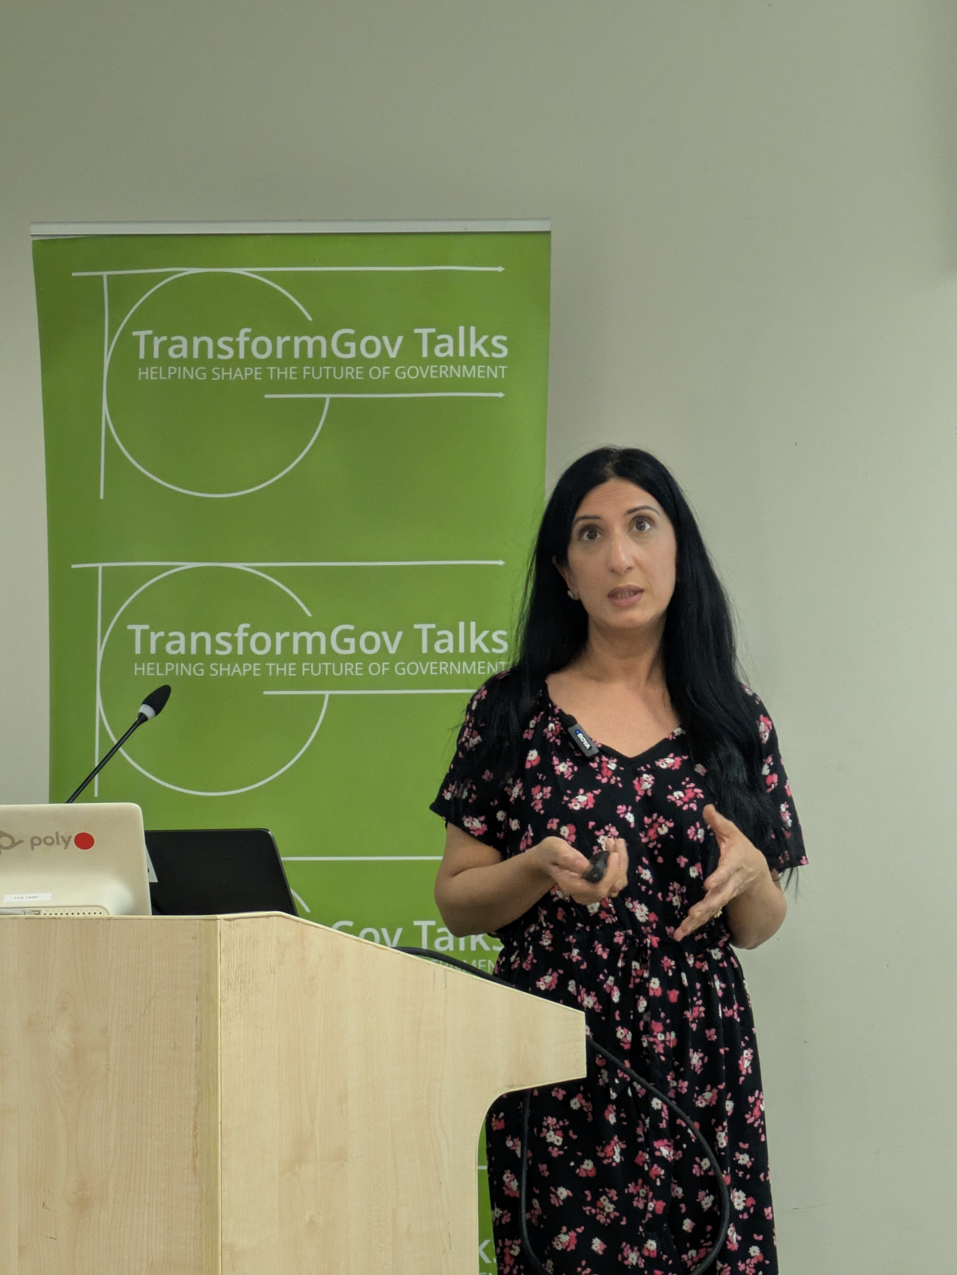
Riz Parveen
Our second speaker was Julia Finch, Director, Athene Leadership, on “Eggs in One Basket: Strategic Risk in an Age of Volatility”.
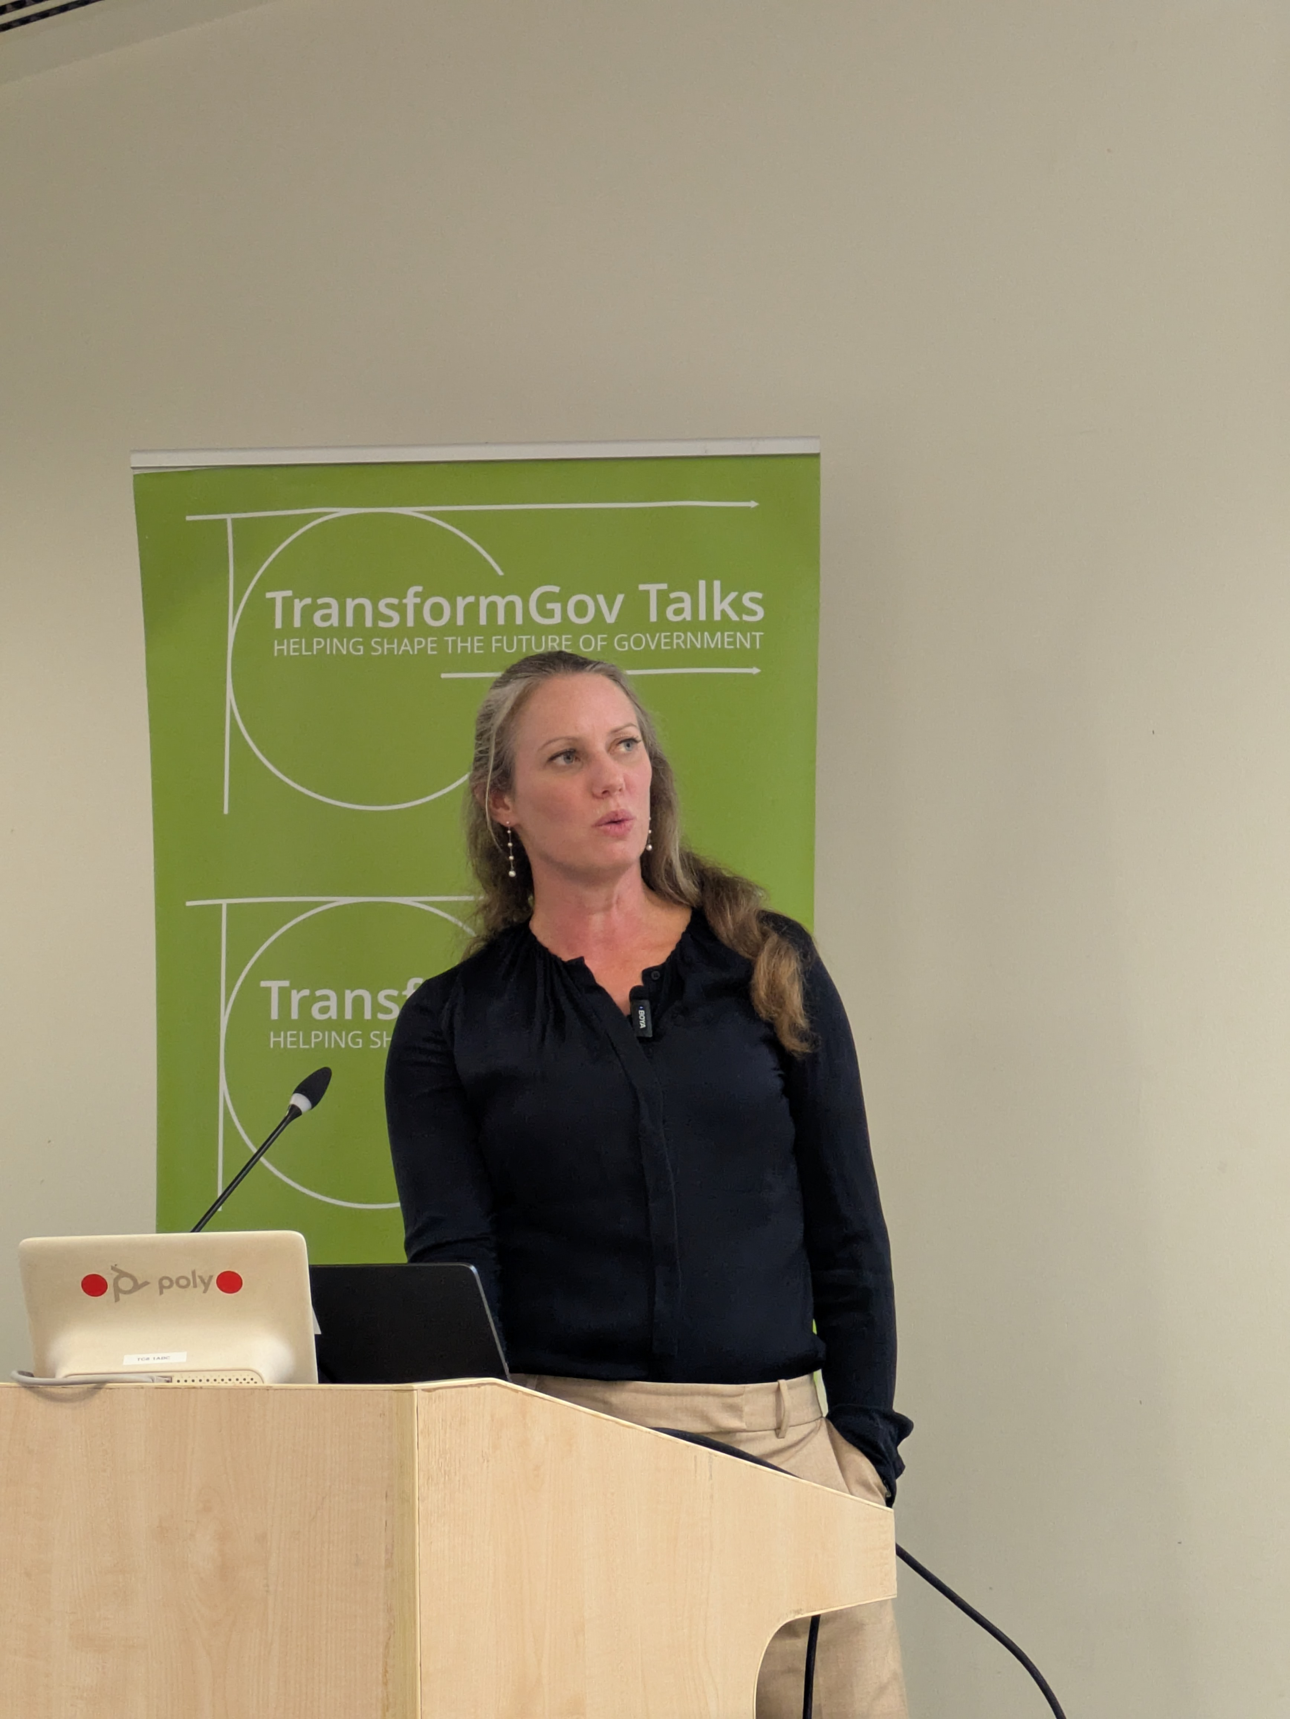
Julia Finch
If you weren’t able to attend, you can catch up on the event in more detail:
- Read the [Gemini AI Summary — link TBD, see note below]
- Video on YouTube: https://youtu.be/0pio6HFWSO8
- Audio version on Spotify: https://open.spotify.com/episode/7kFeIergJysuxfugvFfFaR or Apple Podcasts: https://podcasts.apple.com/gb/podcast/transformgov-talks-september-2026/id1776623246?i=1000792627799
At the end of the event, we included a few parish notices for other events and projects you might be interested in:
Policy Camp · National Conversations · Civic Punks · Data Bites · Think Digital conferences · The National Strategy Project · GovCamp Scotland · GovCamp Cymru
You can also download this poster to put up in your office. If you do — please share a photo with us!
Let us know if you have an event you’d like us to publicise.
Finally, our next event is on 28 October 2026, 6-7pm, at Ministry of Justice, 102 Petty France, London SW1H 9AJ, featuring Harry Trimble (dxw) and Asma Nafees, Deputy Chief Operating Officer, NHS England (Arden & GEM).
You can register now! https://luma.com/424qc6d1

